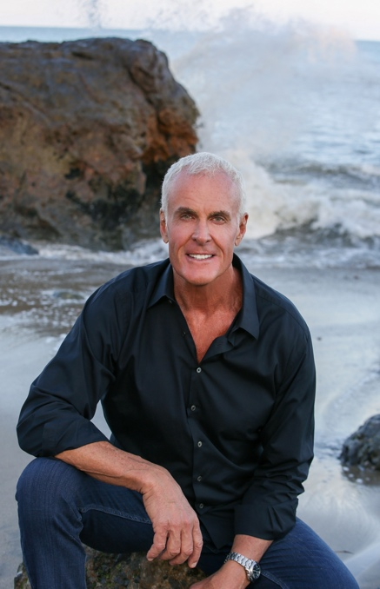
Steve Wright, a playful and innately curious soul, enjoyed an eleven-year professional football career with the Cowboys, Colts, and Raiders, yet these years did not define him.

Driven by his entrepreneurial instincts, he created an innovative misting company, Cloudburst, that cooled professional sports, the US military, NASA, and the 1996 Atlanta Summer Olympics.

His motto to leave people, places, and things better than he found them also led to his work on behalf of Globall Giving to provide gently used sports equipment to over a million children across thirty countries and counting.

Forever a lover of adventure, Steve joined the cast of Survivor for thirty-one days of starvation where he embraced the jungle of Nicaragua and emerged more passionate about life. His journey of continuous growth includes an unparalleled passion for physical and mental fitness which he practices and shares with his community in Malibu, California.

Steve now brings his voice to the public debate on healthy masculinity and more broadly humanity through his memoir, Aggressively Human, inspiring others to embrace empathy and kindness as a complement, not a challenge, to aggression.

