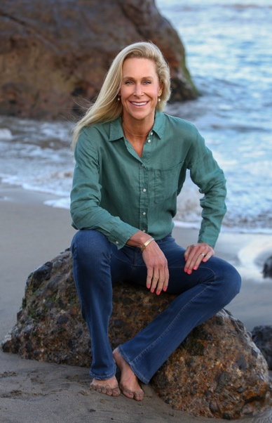
Lizzy Wright’s life has been about taking risks and defying the odds. After decades of driving transformation for businesses and non-profits, she followed her heart into the enchanting world of storytelling. Her education at Harvard and Georgetown and careers in intelligence and consulting honed a distinct analytical eye that enriches Lizzy’s writing.
Her first memoir, Aggressively Human, tackles the uneasy intersection between aggression and empathy. In a world where masculinity is a moving target, it exposes a deeply personal quest to become a healthy, well-adjusted man and a fully realized human being. Her second memoir, Bred to Be?, explores the tumultuous life of Todd Marinovich. Deemed America’s first test tube athlete, the memoir reveals the tapestry of choices and sacrifices made by one of the most misunderstood athletes of a generation.
Lizzy’s espionage thriller, The Saffron Spy, is forthcoming. While immersed in a shadow world, the novel encourages readers to question ethical constructs as individuals, nations, and a global community. Lizzy is uniquely positioned to blend fact and fiction, bringing readers deep into the underbelly of deceit after tracking Osama bin Laden and his direct reports for years.
A lifelong athlete and adventurer, the ocean is Lizzy’s second home, where she contemplates character development and word choice in the surf lineup. She lives her dream with her husband, former NFL athlete Steve Wright, in a laid-back enclave of Malibu, California.

